**Top 5 SMS providers used with Java**

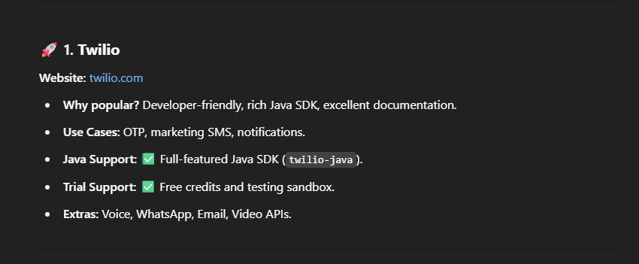

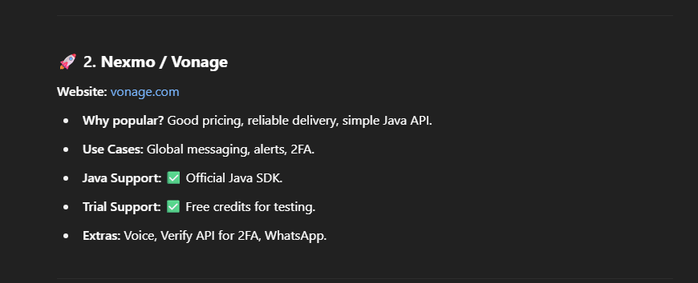

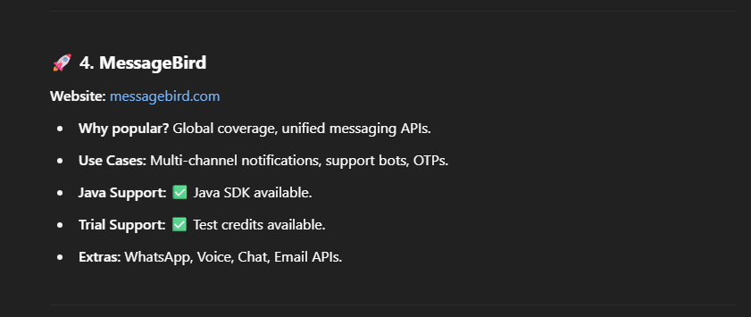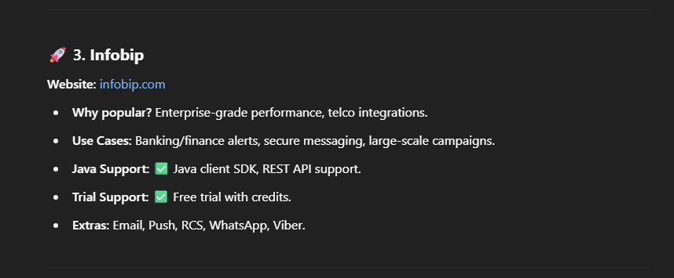

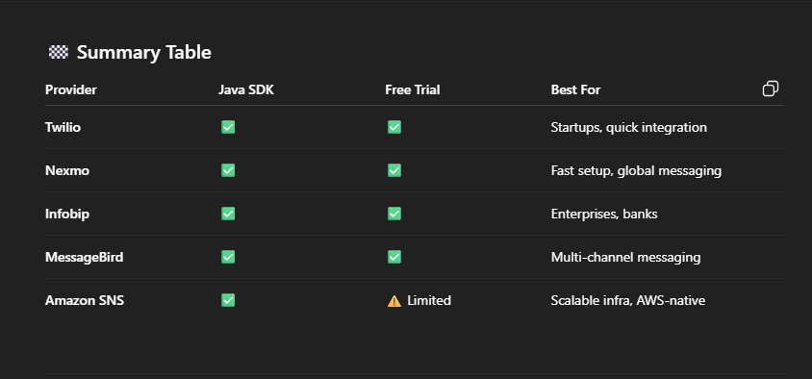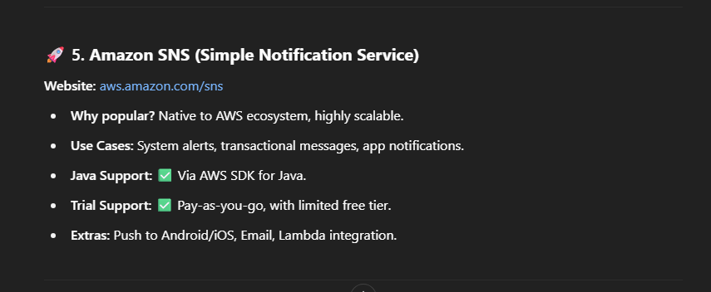

**Our use case:** enable admin to send the request status to the customer via SMS.

So, bases on our use case, **Twilio** or **Infobip** maybe a good choice.

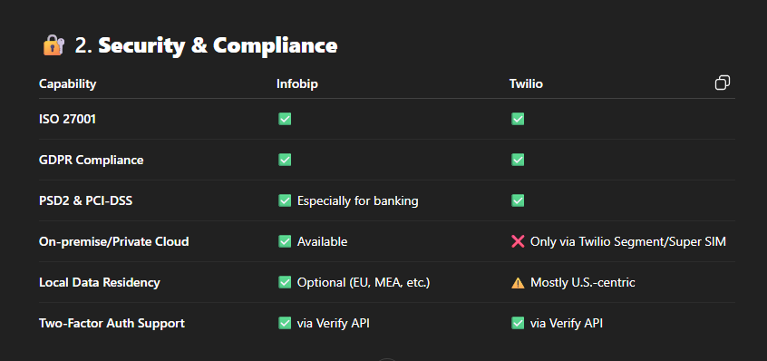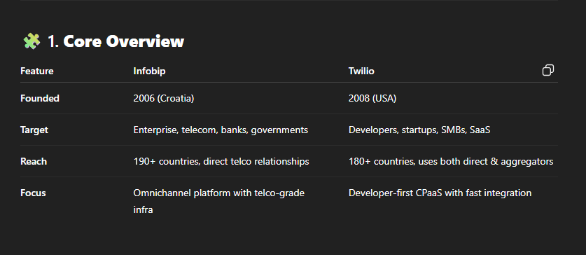Let’s compare:

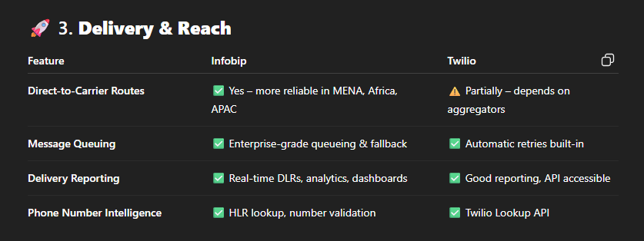**Verdict: Infobip** wins for regulated industries like **banking**, due to **data sovereignty**, **custom deployments**, and better audit options.

**Verdict:**

* **Infobip** is **more reliable globally**, especially in **regulatory-heavy regions** like the Middle East, Africa, and Eastern Europe.
* **Twilio** is fast and effective in the **US/EU**, but can have delivery challenges in some countries.

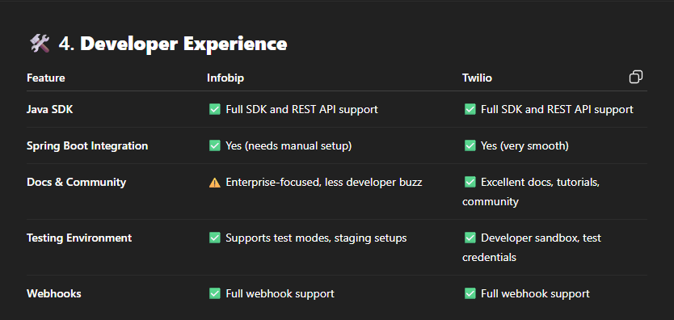 **Verdict:**

* **Twilio** wins for **speed of development** and ease of learning.
* **Infobip** needs more work for setup.

**Verdict:**

* **Twilio** is better for **small/medium use** or quick trials.
* **Infobip** can be **cheaper at scale** or in difficult delivery markets due to their telco relationships.



**Based on this detailed comparison, the decision will be as follow:**

**As a developer:** I will prefer to use **Twilio** as he is a developer friendly and easy to setup and use.

But (مبتتحسبش كده يصحبى)

**From the business side: Infobip** will be the best choice due to itssecurity, data compliance, delivery on MENA, price, and more.

**But now, we are facing a problem:**

Egypt's National Telecom Regulatory Authority (NTRA) imposes **strict rules on international SMS and voice traffic**, especially from foreign providers like Twilio.

Also, these international providers is not cheap.

So, instead of using foreign SMS providers we can use local providers like SMS-Misr, or Infobip’s Egypt-compatible sender.

Another Egyptian possible solutions:

1. **BeOn:** [BeOn - حلول الرسائل النصية وOTP الأسرع والأكثر كفاءة في مصر](https://beon.chat/ar/#!)
2. **Ecc Solutions**
3. **Link Development**

**----------------------------------------------------------------------------------------**